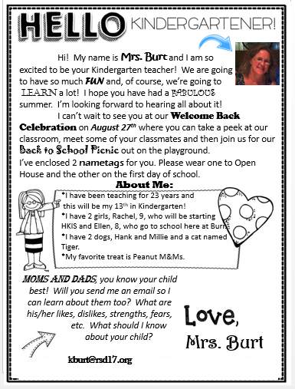

Here’s some important information you will want to know

* School starts at 8:35 and ends at 3:25.
* If you plan to pick up your child, they can be picked up in the cafeteria
* Please send in a note if there is any change in dismissal.
* If your child goes to the After School program or an after school activity, we will escort them at the end of the day.
* Kindergarteners are met at the bus in the morning and escorted to the classroom and will be escorted back to their bus lines in the afternoon.
* Breakfast (snack) and lunch are served daily.  The cost of breakfast is $2.25, lunch is $3.25 and milk is $0.65